FET PRACTICAL-7

**Objective: To understand the usage of modules in EcmaScript.**

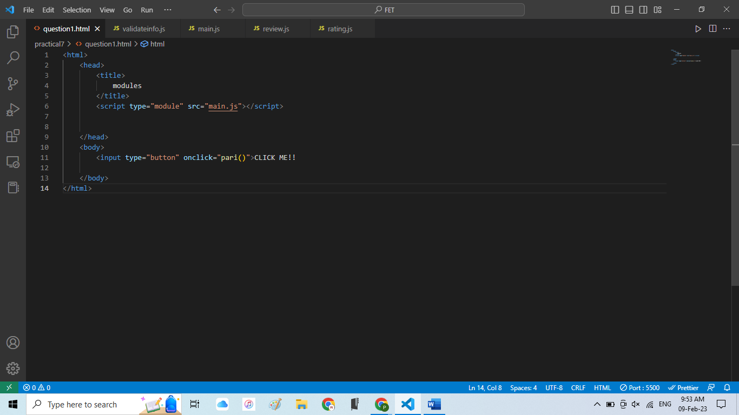

**MAIN FILE:-**

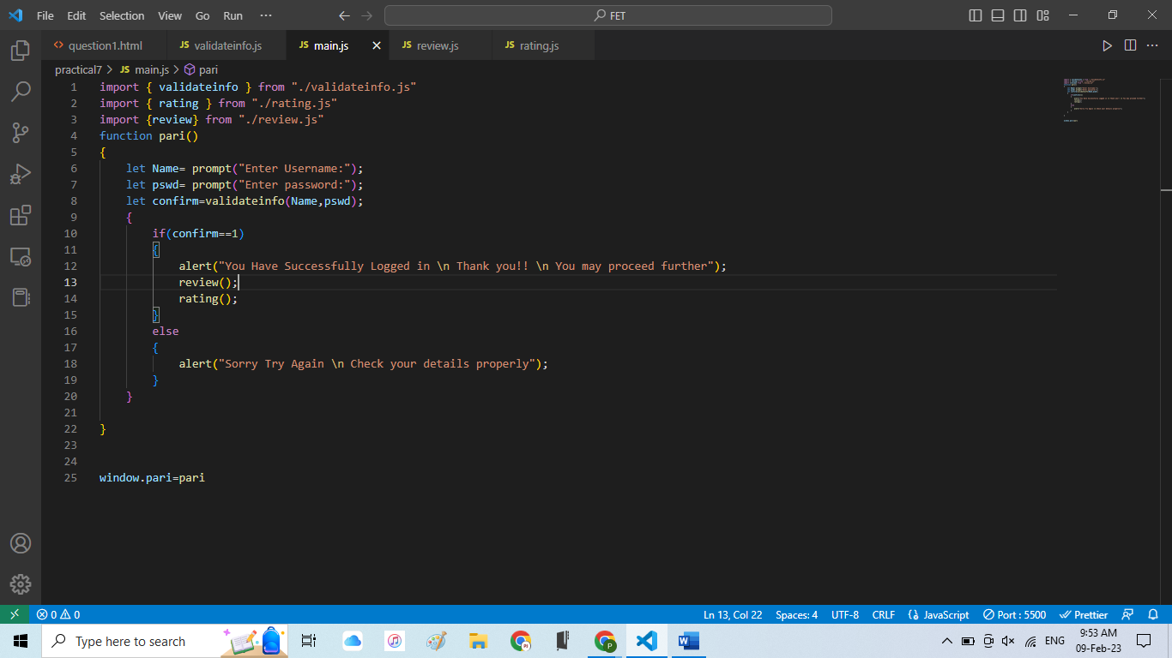

**VALIDATE INFO FILE:-**

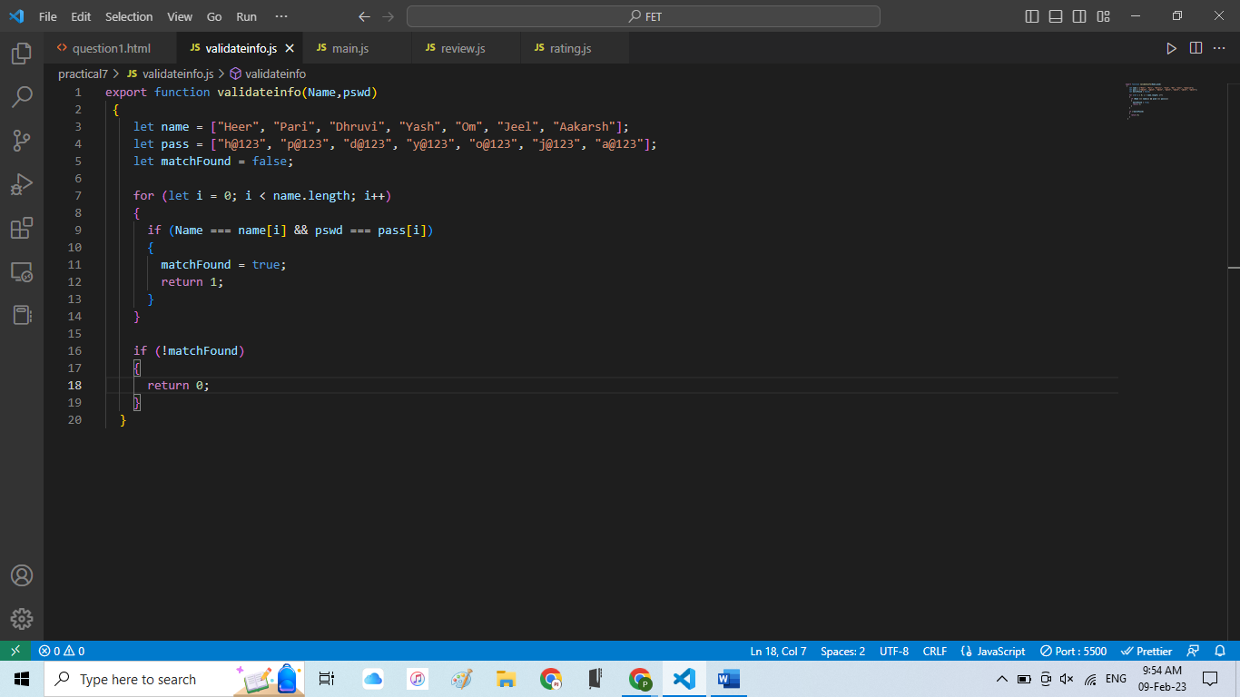

**REVIEW FILE:-**

**RATING FILE:-**

**OUTPUT:-**

